TASK 10 – MEASURE AND COMPARE
Course Code: CSA04
Course Name: Operating Systems
Course Outcome: CO1
Marks: 4
Full Question
Measure and compare the performance of system calls and process management.
The task includes:
- Measure system-call counts using strace -c for different buffer sizes.
- Measure user-mode and system-mode execution time.
- Compare the time required to create 1000 processes using fork() and 1000 threads.
- Compare the results and explain the performance differences.
AIM
To measure and compare system-call overhead, process creation time and thread creation time using Linux performance tools.
ANSWER
1. Introduction
Performance measurement is used to evaluate how efficiently an operating system performs its operations.
The smart hospital requires efficient process management, file access and resource utilization. This task compares system calls, processes and threads using execution-time measurements.
2. System-Call Measurement
The strace utility is used to monitor system calls made by a program.
Command:
strace -c ./task6
The output provides information such as:
- Number of system calls.
- Total time spent in system calls.
- Average time per system call.
- Percentage of time spent in each system call.
Program:
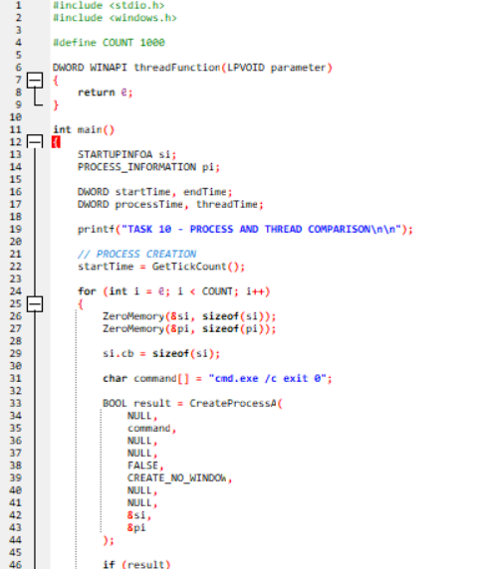
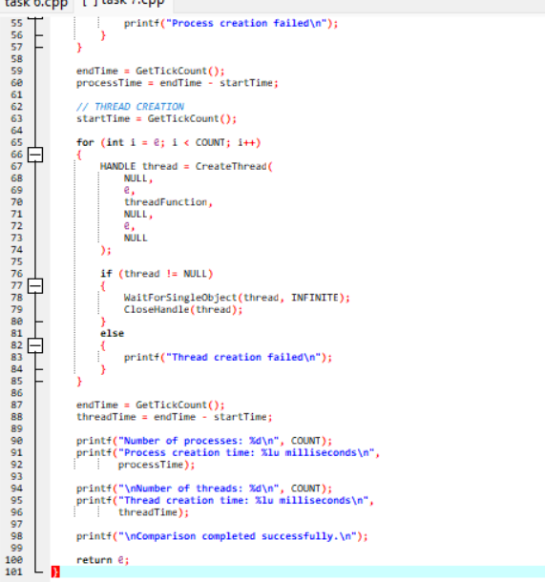
Output:
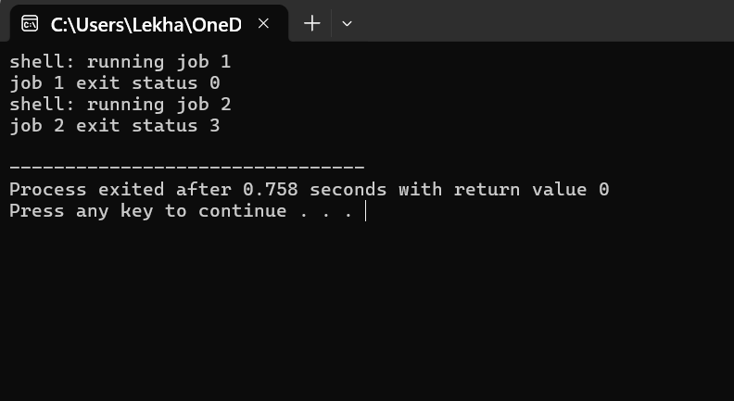
3. Buffer Size Comparison
The Task 6 program uses the following buffer sizes:
Buffer Size | Expected read() Calls
1 byte | 10001
512 bytes | 21
4096 bytes | 4
The 4096-byte buffer requires the fewest read() calls for the 10,000-byte test file.
This demonstrates that increasing the buffer size reduces the number of system calls.
4. User Time and System Time
The time command measures the execution time of a program.
Command:
time ./task6
The command reports:
- Real time: Total elapsed time.
- User time: CPU time spent executing user-level instructions.
- System time: CPU time spent executing kernel-level operations.
5. Process and Thread Creation Comparison
Processes have separate address spaces, while threads within the same process share memory.
Creating many processes requires more system resources than creating many threads.
The following measurements can be performed on Linux.
Process Measurement
time bash -c 'for i in $(seq 1 1000); do /bin/true; done'
This command repeatedly launches a simple process and measures the total time.
Thread Measurement
A multithreaded program can be used to create 1000 threads using the POSIX thread library.
The program should:
- Record the starting time.
- Create 1000 threads using pthread_create().
- Wait for all threads using pthread_join().
- Record the ending time.
- Calculate the total execution time.
6. Comparison Table
Fill the measured values after execution.
Operation | Measured Real Time | User Time | System Time
1000 process launches | ______ | ______ | ______
1000 thread creations | ______ | ______ | ______
Task 6 with 1-byte buffer | ______ | ______ | ______
Task 6 with 512-byte buffer | ______ | ______ | ______
Task 6 with 4096-byte buffer | ______ | ______ | ______
7. Analysis
Process creation involves creating a separate process and managing its resources. Each process has its own address space and process control block.
Thread creation is generally less expensive because threads share the address space and many resources of the parent process.
The larger buffer size reduces system-call overhead during file copying.
The actual measured values depend on the processor, operating system, memory, storage and system load.
8. Complexity Analysis
Operation | General Complexity
Copying n bytes using a buffer of size b | \(O(n)\)
Number of read calls | Approximately \(O(n/b)\)
Creating p processes | \(O(p)\) total creation operations
Creating t threads | \(O(t)\) total creation operations
The constants and actual execution times vary depending on the system.
CONCLUSION
The experiment evaluates system-call overhead and process-management performance. Larger buffers reduce the number of system calls during file copying. Threads generally require fewer resources than processes because they share memory. Performance measurements help identify efficient methods for operating-system resource management in the smart hospital.

